Tutorial 2

Composing metamodels using GME 3

Composing metamodels
First, we shall build the metamodel for a signal flow paradigm. Then you will need the metamodel of the finite state machine paradigm created in Tutorial 1 (FSM-Meta.mga). Using these two metamodels we shall compose a metamodel specifying a new modeling paradigm.

Prepare the component metamodels
Recall the steps of creating the metamodel of the finite state machine paradigm (See Tutorial 1). These steps will not be discussed afresh. We shall only explain the metamodel creation of the signal flow paradigm.

Create the metamodel of the signal flow paradigm
The simplest part of our signal flow metamodel is the signal itself. Signals could be input or output signals but most of their properties are the same. The common method to capture this perception in our metamodel is to derive both the input and the output signal atoms from a base signal atom. We use the “Inheritance” operator () for this. You may want to specify your Signal atom as an “Abstract” class (right click the Signal atom and check the “Abstract ?” attribute), since you only want to create input signals and/or output signals. We only needed the Signal atom as common base class. You can see the result in Figure 1.
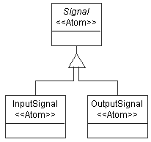
Figure 1: Inheritance
Signals can be connected to form the signal flow. We need a connection object (Dataflow) and a connector to describe the relationship of these objects. Both input signals and output signals can be connected together, so it is convenient to make this relationship at the base signal object (See Figure 2).
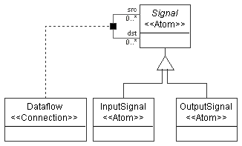
Figure 2: Dataflow
The signal atom and dataflow connection are both parts of a processing environment. Furthermore, Signal atom will act as a port of the Processing model. In our model, we have primitive processes and compound processes. Primitive processes are the leaf nodes in the signal flow hierarchy that implement elementary computations in the graph. Compound processes can contain signals, primitives and/or other compound processes. While assigning the signal atom and dataflow connection to models, we should keep these rules in mind. Again, Processing model will be an abstract model, since we only want to instantiate Primitive and Compound processes in our signal flow model.
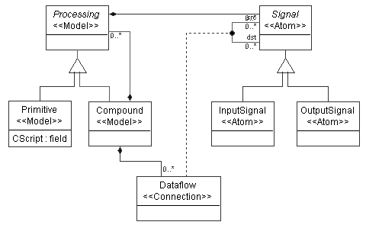
Figure 3: Class diagram of signal flow model
To make Signal atoms appear as GME ports in Processing models left click on the containment connection between the Signal atom and the Processing model and make the “Object is a port?” attribute in the Attribute Panel “true”. Make sure the Attribute Panel shows the attribute settings for the containment you meant to. We did not give a special name to this connection, so you should see the default name “Containment” in the Attribute Panel indicating the active object with the revealed settings.
Set the “In root folder?” attribute for the Compound model. See Figure 3 for our final metamodel of the signal flow paradigm.
We need to define an attribute of the Primitive class. Following the steps in Tutorial 1, switch to Attribute aspect and add a field attribute to the Primitive class. We can name it “CScript”. In the signal flow models this attribute will contain the C function that implements the functionality of the given Primitive.

Interpret the signal flow metamodel
This goes just like in Tutorial 1. Do not forget to specify an aspect for your metamodel. This time you need to assign it to the Processing model so that you have all your objects in it. Defining it to any other model objects of your metamodel will cause a warning signal interpreting your metamodel indicating that not all of your objects are assigned to an aspect. Save your metamodel as SF-Meta.mga.

Export metamodels to XML format
GME 3 provides a bi-directional XML access for both model and metamodel information. You can generate XML format of your metamodel by invoking File/Export XML. Please, export both your finite state machine and signal flow metamodels to XML format.

Composition of two existing metamodels
In this section, we shall use the two exported metamodels to create a metamodel of a more complex signal flow paradigm.

Load the existing metamodels
First, following the steps in Tutorial 1, create a new project in GME 3. Invoke File/Import XML and select your XML file for the finite state machine. Press Open. Do the same steps to import your exported signal flow metamodel !

Create the composite metamodel
We would like to have a new kind of signal flow process that can contain a finite state machine specifying its implementation as opposed to the current Primitive that has the “CScript” attribute specifying its implementation. However, we do not want a regular state machine (i.e. State) to be able to contain this new kind of model. In other words, we cannot use the State model as a base class of this new model using regular inheritance.
In GME 3 new inheritance operators were also introduced to provide finer control over inheritance. When the new class needs to be able to play the role of the base class, but its internals need not to be inherited, we use interface inheritance. In this case, all associations and those compositions where the base class plays the role of the contained object are inherited. On the other hand, when only the internals of a class are needed by a subclass, we use implementation inheritance. In this case, all the attributes and those compositions where the base class plays the role of the container are inherited. Notice that the union of these two new operators is the standard UML inheritance.
Following the steps in Tutorial 1, insert a new paradigm sheet into the root folder. In this case we need to define a new class (FSMNode) that inherits from both Primitive and State. Inheriting from State through standard UML inheritance would mean that a State could contain this new type of node violating one of our objectives. Instead, we use implementation inheritance, which means, FSMNode can contain whatever a State can, but it cannot act as a State. Hence, it cannot be inserted into a State. Neither can FSMNodes be connected together by Transitions.
Let’s create the class diagram! For Primitive and State we can use proxies, i.e. references pointing to classes defined elsewhere in our metamodel. To define a proxy, drop a proxy class onto your sheet. Note that we need model proxies for Primitive and State. At this point these references (i.e. the proxies) do not refer to anything. To make them refer to a specific class, open the proper paradigm sheet you imported and drag and drop one of the above-mentioned classes onto your proxy. Even if you have created the reference properly, you will not see any actions confirming your steps, but if you right click on your proxy object and select the Properties option you will see in the Refers list box the reference you have created. (Or you can use the tooltip feature: move your mouse over the proxy and wait until a yellow label pops up.)
You can see this part of the class diagram in Figure 4.
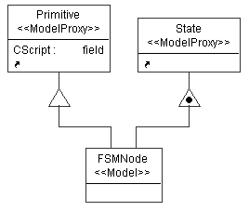
Figure 4: Implementation inheritance in FSMNode
Next, we want to make the input signals and output signals of the FSMNode process to be mapped to certain States it contains using connections. To achieve this, we introduce a new type of connection (SignalMap) connecting States and Signals together. This connection will be contained in the new FSMNode class only. To make this connection bi-directional – as desired – clear the default rolename (“src” and “dst” respectively) in the Attributes window of both connections drawn to the connector object.
For the Signal we can use an atom proxy. An alternative way of creating a proxy (reference) in GME 3 is dragging your class from its definition window and dropping it onto your new paradigm sheet while holding down the CTRL and the SHIFT keys.
Figure 5. shows the final composed metamodel with new SignalMap connection.
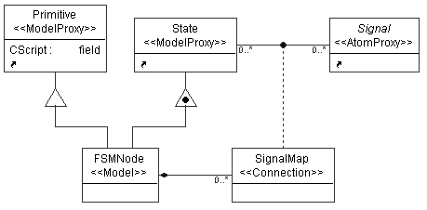
Figure 5: Class diagram of the composed metamodel

Define the aspects for your composite metamodel
Switch to the Visualization aspect of your metamodel. You can define an aspect to the new metamodel by using the aspects of the imported paradigms. You need to create a new aspect and two aspect proxies referring to the aspects of the imported paradigms. The equivalence operator can define the relationship of these aspects. Drag two SameAspect objects onto your sheet. Place one between the two aspect proxies and one between the new aspect and an aspect proxy. To make sure that the new aspect is called Composite, name the SameAspect object between the SignalFlow aspect proxy and the FSM aspect proxy “Composite”. Your aspect definition is shown in Figure 6. You can find more about aspect equivalence in GME 3 User’s Manual.
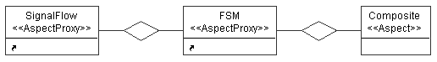
Figure 6: Aspect of the composite metamodel
Switch to Set Mode and right click the new Composite aspect. The only class you have to assign to this aspect by left clicking on it is the SignalMap connection.
To be able to use a composite signal flow paradigm, create it first by interpreting your metamodel. After you have it successfully interpreted, register your new paradigm.

Use the composite paradigm to create domain-specific models
We demonstrate how to apply the created paradigm through a simplified model of a washing machine. Following the steps in Tutorial 1, close your previous project and create a new one based on the new hybrid signal flow – finite state machine paradigm. In the Browser window, right click to insert a Compound model into your root folder.
Now you can create a composite signal flow. A simplified model describing a washing machine is shown in Figure 7. The white colored Control System is an FSMNode , the light green (light gray) Logics are Primitives, and the whole system is in a Compound process. The Control System is described by a state machine. (See Figure 8.) The dark green (dark gray) colored boxes stand for States.
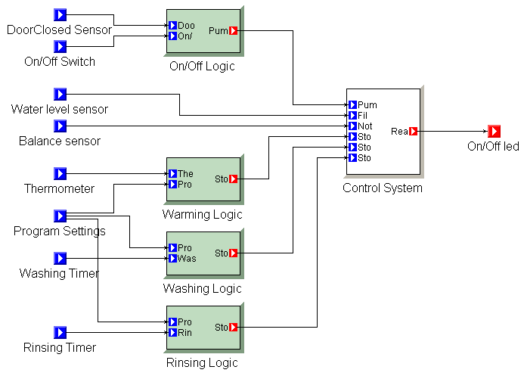
Figure 7: Laundry model
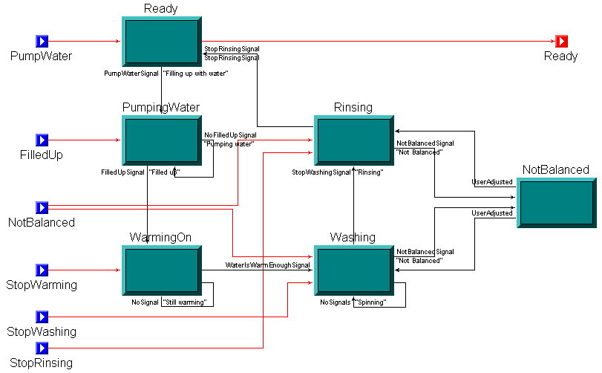
Figure 8: State machine in compound process
You can define your own icon files for objects by setting the Icon name and Port icon name attributes of the classes in the Attributes window. It makes sense to define your own icon path by invoking File/Settings…in the target environment and giving only the file name and its extension in the Attributes window in the metamodels. The difference between Primitive models, Compound process models and FSMNode models can simply be indicated by defining different colors for different model classes, too. You can change the color of the model boxes in the Preferences window by setting the Color property.

Note: It isn’t the same how you create the connections between the inheritance operator and the related objects. The best way to avoid mistakes is to keep a top-down direction: (1) first, connect the base class to the inheritance operator, (2) then connect the inheritance operator to one of the objects to be derived. Repeat the second step until you connected each derived object as desired.

